

z

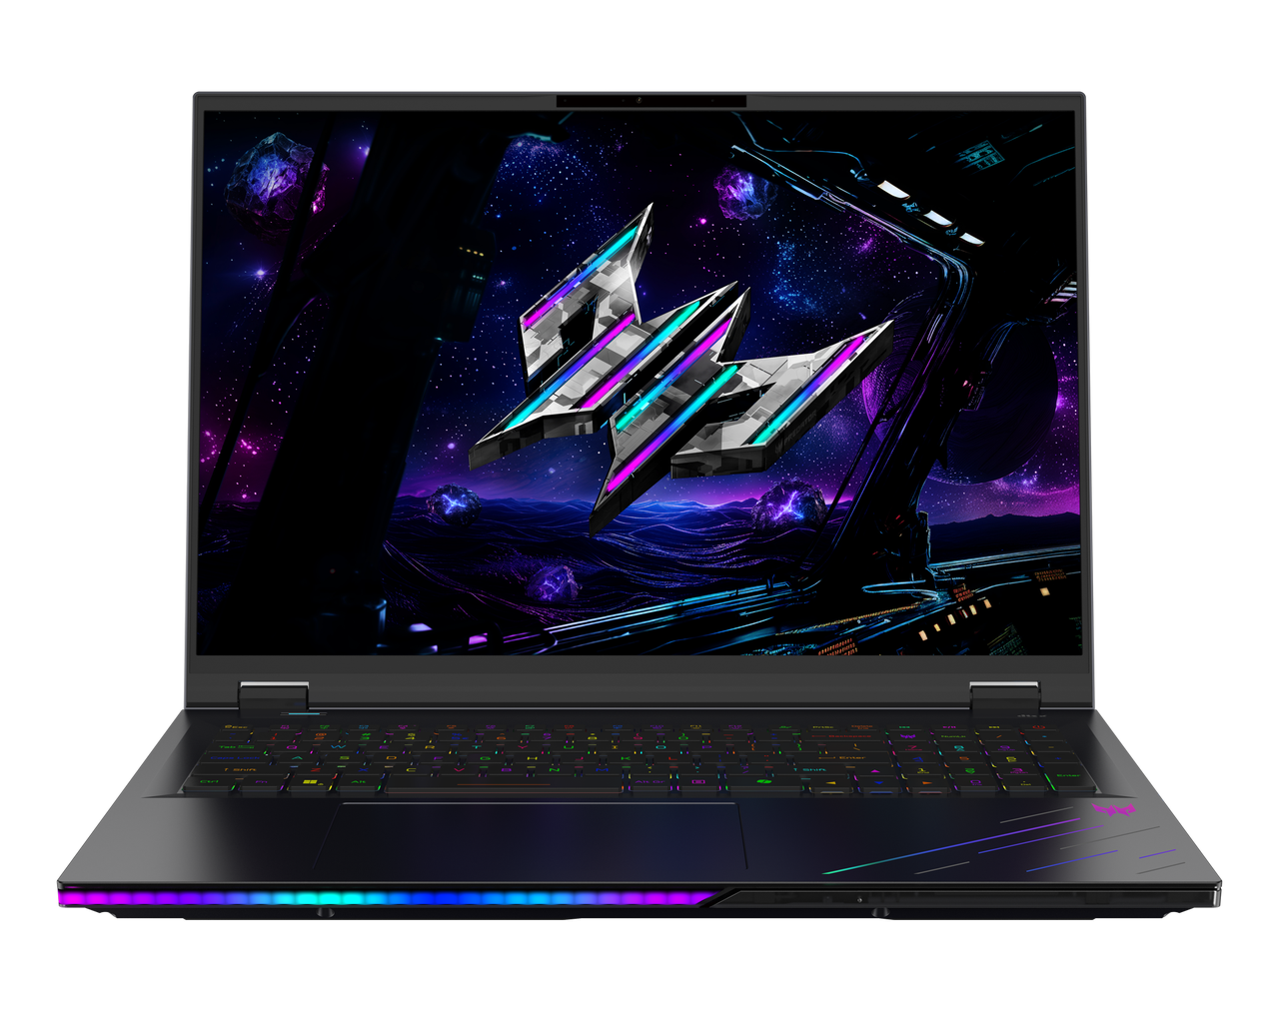

PREDATOR HELIOS 18 AI

SPECIFICATIONS PREDATOR HELIOS 18 AI PH18-I71

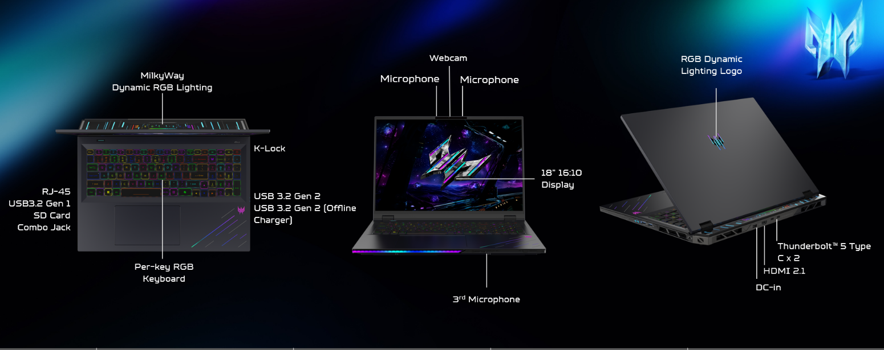
Operating System |  | Windows 11 Home  Windows 11 Pro
CPU and Chipset |  | Intel® Core™ Ultra 9 processor 290HX Plus
Memory |  | Dual-channel DDR5 SDRAM support  Up to 192 GB of DDR5 system memory using four soDIMM modules |  | Default Dual-channel DDR5 SDRAM support 4400 MT/s (Under 1or 2 SODIMM)  Default Dual-channel DDR5 SDRAM support 4000 MT/s (4 SODIMM)
Display |  | 18.0" display with IPS (In-Plane Switching) technology | WQUXGA 3840 x 2400 | High brightness: SDR 600 nits / HDR 1000 nits | 100% DCI-P3 | Acer ComfyView™ LED-backlit TFT LCD | Integrated Mini LED technology  •Supporting frame rate 120Hz & GTG 3ms by Overdrive,  •NVIDIA Advanced Optimus capable and HDR 1000.  •16:10 aspect ratio with Wide viewing angle up to 170 degrees  •Mercury free, environment friendly |  | 18.0" display with IPS (In-Plane Switching) technology | WQXGA 2560 x 1600 | High brightness: SDR 600 nits / HDR 1000 nits | 100% DCI-P3 color gamut | Acer ComfyView™ LED-backlit TFT LCD | Integrated Mini LED technology  •Supporting frame rate 250Hz, GTG 3ms by Overdrive,  •NVIDIA Advanced Optimus capable and HDR 1000.  •16:10 aspect ratio with Wide viewing angle up to 170 degrees  •Mercury free, environment friendly
Graphics |  | NVIDIA® GeForce RTX™ 5090 24 GB GDDR7  NVIDIA® GeForce RTX™ 5080 16 GB GDDR7
Audio |  | Quad + Dual Speakers output with smart amplifier enhancement and Acer TrueHarmony technology for lower distortion, wider frequency range, headphone-like audio, and powerful sound | DTS® X: Ultra Audio featuring optimized bass, loudness, and speaker protection with up to 6 custom content modes powered by smart amplifier |  | Immersive audio rendering over headphones and internal speakers  Acer Purified Voice technology with AI noise reduction using a 3-microphone array to support Advanced
 |  | Active-forced vibration cancellation dual speaker module design to enhance speaker performance and reduce system resonance | Supported in Windows Spatial Sound for PC Gaming with DTS Sound Unbound license integrated |  | High SNR DAC with 2.1 Vrms output capability, capable of driving high impedance headphones up to 600 ohms
Storage |  | Solid state drive: 2 TB / 1 TB PCIe Gen5 SSD | HDD2: Support Gen4 SSD 1 TB | HDD3: Support Gen4 SSD 1 TB
Webcam |  | Video Conferencing  UFC with narrow USB FHD camera and IR camera | Windows compatible only | 1920 x 1080 | 1080p with temporal noise reduction | Blue glass lens | SHDR | Dual mic 33 mm + 33 mm | 88 x 3.2 x 2.6 mm
Wireless and Networking |  | WLAN:  Killer™ Wi-Fi 7 wireless LAN  802.11 a/b/g/n/ac/ax/be  Band: 2.4 GHz, 5 GHz, and 6 GHz  2x2 MU-MIMO technology | LAN:  Killer™ Ethernet E5000B  5G Ethernet  Killer Control Center  Lag and latency reduction™ technology  Advanced Stream Detect™ 2.0  Killer DoubleShot™ Pro enabled  GameFast™ technology |  | WPAN:  Supports Bluetooth® 5.4 or above  Supports Bluetooth LE Audio (LC3)
Security |  | Firmware Trusted Platform Module (TPM) solution | BIOS user, supervisor passwords | Kensington lock slot
Dimensions and Weight |  | Dimensions  400.96 (W) x 307.9 (D) x 29.55/17.3 (H) mm (15.79 x 12.12 x 1.16/0.68 inches) with Metal A Cover |  | Weight  3.5 kg (7.72 lbs.) with 4-cell battery pack, miniLED display
Power Adapter and Battery |  | Power Adapter  400 W AC adapter  • 20 V / 20 A as output power  • 188.0 (W) x 88.0 (D) x 33.0 (H) mm  • 980 g with 120 cm DC cable  • Black color | Battery  • 99.98 Wh 4-cell Li-ion battery  For models with WQUXGA Panel  Battery life:  • Up to 3 hours (based on MobileMark® 2030 test results)  • Up to 5.5 hours (based on video playback test results)  • Up to 5 hours (based on web browsing test results)
Input and Control |  | Keyboard  103(US)-/104(UK)-key, FineTip RGB mini-LED Per-Key backlight  keyboard with international language support  • Backlit chiclet keyboard with individual LED(s) under each keycap  • 100% Anti-ghosting  • Keybaord travel distance 2.0mm for gamer optimal typing feel  • Switchable Mag_key 4.0 for WASD and Cursor keys  • Copilot key design  • Interactive Lightening  • Key-to-key area: 339.45mm (width) *107.35mm (Length) | Touchpad  Multi-gesture touchpad, supporting two-finger scroll; pinch; gestures to  open Cortana, Action Center, multitasking; application commands  • Microsoft Precision Touchpad certification  • Moisture resistant  • Corning® Gorilla® Glass |  | Control Keys  Mode Key  Predator Sense Key  Copilot Key  (Notes: (Notes: XG05P_P50BPK for Copilot feature with Windows.))
Options and Accessories |  | Accessory  Predator MagKey 4.0 Eight-in-One Box Accessory | Predator MagKey 4.0 Eight-in-One Box | One set of MagClick, swappable switch keycaps, 8 pcs per set for WASD and cursors | One key-puller | One bulk pack |  | Predator memory thermal upgrade kit  Thermal sheet for 16GB memory only: Thermal sheet x4 |  Thermal pad for 32GB or 48GB only: Thermal pad 5.5 mm x1 | Thermal pad 1.5 mm x2 | Thermal pad 0.75 mm x2 |
Windows Desktop Apps |  | In-House Applications  Acer LiveArt | Acer QuickPanel | Acer VisionArt | PredatorSense V5 (NB) |  | Tools  Acer My Key Application
Warranty |  | One-year International Travelers Warranty (ITW)
Disclaimers
• | Specifications vary depending on model.
• | Shared system memory may be allocated to support graphics, depending on system memory size and other factors. Actual system memory available to the operating system will be reduced by any memory used by the graphics solution and resources required by the operating environment.
• | Memory speed may vary, depending on the CPU, chipset, or memory fitted.
• | All brands and product names mentioned herein include trademarks of their respective companies and are used solely to describe or identify the products.
• | 1 GB is 1 billion bytes. Actual formatted capacity is less and may vary depending on preloaded materials and operating environment. Acer Recovery Management uses a portion of the stated hard disk capacity as dedicated backup space.
• | Minor variations in system dimensions are possible due to the manufacturing process.
• | Weight may vary depending on product configuration, vendor components, manufacturing variability, and selected options.
• | Listed battery life is based on testing using video playback. The test clip loops and continues to run, without interruption or any other inputs, until the battery is drained. Stated battery life is for comparison purpose only. Actual battery life varies by model, configuration, applications, video chip format, and features used. A battery's maximum capacity decreases with time and use. Battery life test configuration: 15th Gen Intel® Core U9 Refresh processor, NVIDIA® GeForce RTX™ 5090, WQUXGA 4K, triple SSD, 192GB DDR5 memory. Battery life test condition: LCD brightness 150 nits, connected headphones, WLAN off, Bluetooth off, Better Battery Mode on.
• | Listed battery life is based on testing using web browsing. The test loops the loading of 50 selected websites using Microsoft Edge every 30 seconds until the battery is drained. Stated battery life is for comparison purpose only. Actual battery life varies by model, configuration, applications, video chip format, and features used. A battery's maximum capacity decreases with time and use. Battery life test configuration: 15th Gen Intel® Core U9 Refresh processor, NVIDIA® GeForce RTX™ 5090, WQXGA, triple SSD, 64GB DDR5 memory. Battery life test condition: LCD brightness 100 nits, speaker volume 50%, WLAN on, Bluetooth on, no WWAN direct Internet connection.
• | Actual battery life may vary considerably by specifications, depending on product model, configuration, applications, power management settings, operating conditions, and features utilized. Performance variation also arises based on components in use, including but not limited to the processor, RAM capacity, storage, display, and resolution.
• | Bundled software may vary depending on hardware configuration, operating system, and regional availability.
Product sheet specification based on Predator PH18-I71 Specifications (v2-0-1) (Preview)

